|  |  |
| --- | --- |
| **Data Structures & Algorithms**  Diploma in CSF, IT  Year 2/3 (2020/21) Semester 4/6 | **Week 9** |
| **2 Hours** |
| **Tutorial 9 – Trees** | |

1. Draw a **full** binary tree of height 3.

How many nodes are there in a **full** binary tree of height 3?

Number of Nodes = 23 -1 = 7

How many nodes are there in a **full** binary tree of height 10?

Number of nodes = 210 -1 = 1023

1. Draw 3 **complete** binary trees of height 3.

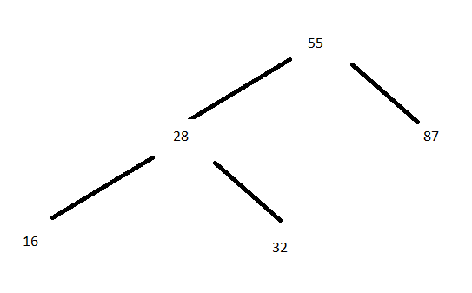

1. Draw any 2 binary trees of height 3 that are neither **full** nor **complete**.

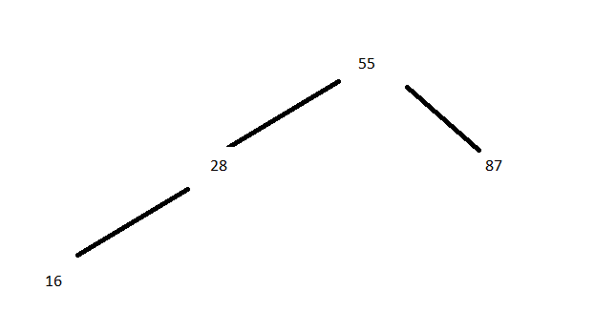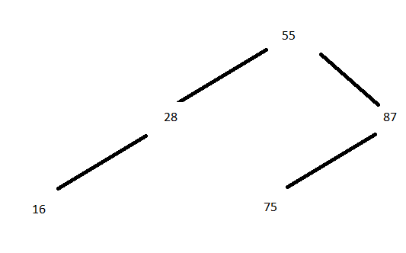

4. A binary search tree is to be created with the items given below.

55 28 87 32 90 16 45 79 66 37

Assuming the items are inserted in the order given (i.e. from left to right),

1. Draw the binary search tree after the items are inserted

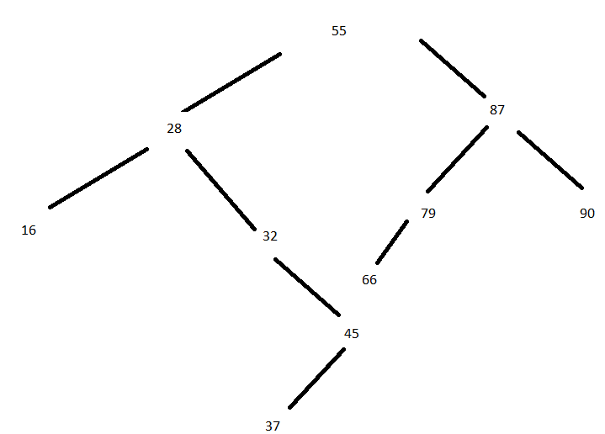

1. Is the binary search tree balanced ?

No

1. What is the output when the tree is traversed ***inorder*** ?

16, 28,32,37,45,55,66,79,87,90

1. What is the output when the tree is traversed ***preorder*** ?

55,28,16,32,45,37,87,79,66,90

1. What is the output when the tree is traversed ***postorder*** ?

16,37,45,32,28,66,79,90,87,55

1. What is the output when the tree is traversed ***level order*** ?

55,28,87,16,32,79,90,45,66,37

5. A binary search tree is to be created with the items given below.

55 28 87 32 90 16 45 79 66 30

Assuming the items are inserted in the order given (i.e. from left to right),

1. Draw the binary search tree after the items are inserted

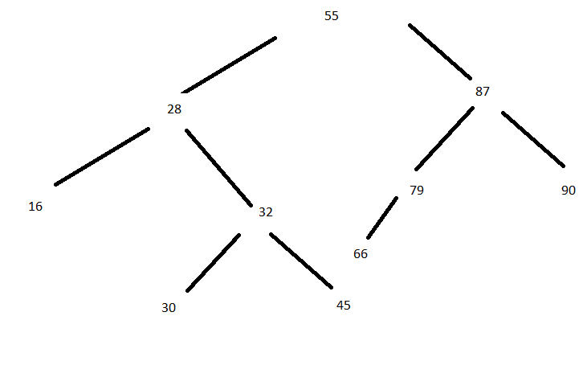

1. Is the binary search tree balanced ?

no

1. What is the height of the binary search tree ?

4

1. What is the worst case comparisons required to search for an item ?

4

1. What is the result when 88 is inserted into the tree ?

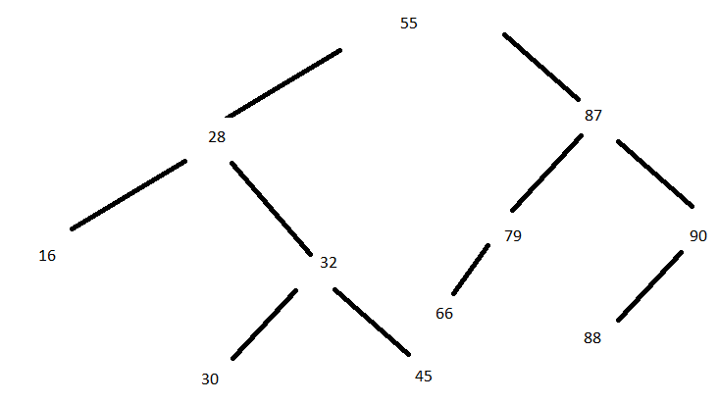

1. What is the result when 16 is deleted from the tree ?

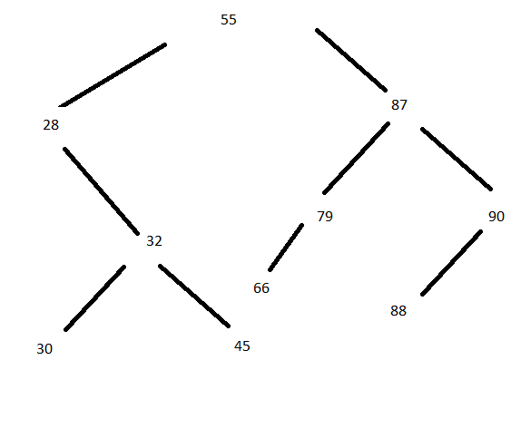

1. What is the result when 79 is deleted from the tree ?

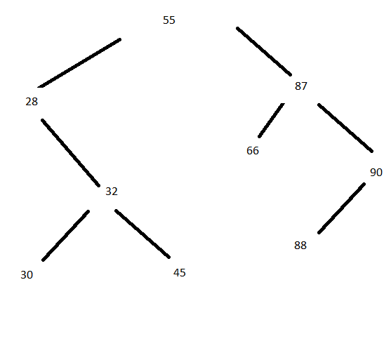

1. What is the result when 32 is deleted from the tree ?

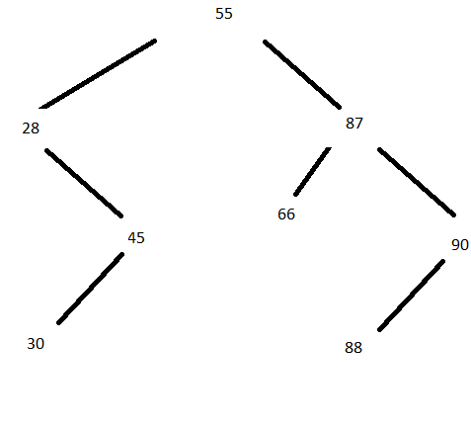

6. A binary search tree is to be created with the items given below.

16 28 30 32 45 55 66 79 87 90

Assuming the items are inserted in the order given (i.e. from left to right),

1. Draw the binary search tree after the items are inserted

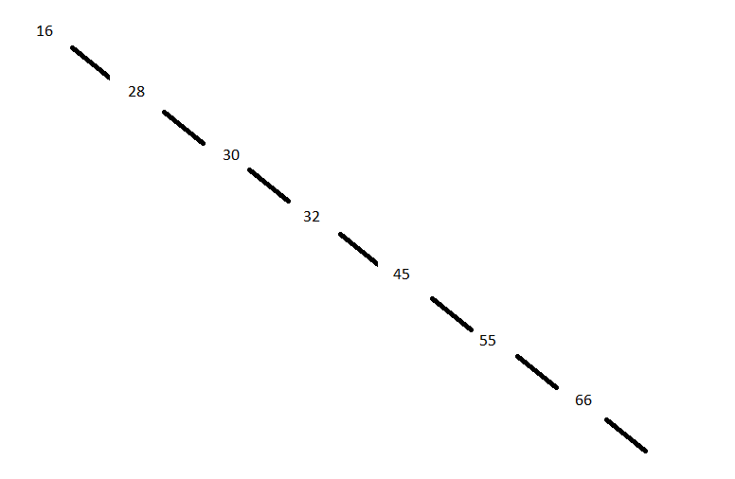

1. Is the binary search tree balanced ?

no

1. What is the height of the binary search tree ?

10

1. What is the worst case comparisons required to search for an item ?

10